

***Soil Science Department***

***Watershed Systems Research Program***

SOIL AND SEDIMENT COLOUR ANALYSES BY DIFFUSE REFLECTANCE SPECTROMETRY

***Standard Operation Procedure***

AUTHOR:

Louise Barthod  30 May, 2013

APPROUVED:

Eva Slavicek May, 2013

David Lobb May, 2013

REVIEWED:

|  |  |  |  |  |  |  |  |
| --- | --- | --- | --- | --- | --- | --- | --- |
| Initials |  |  |  |  |  |  |  |
| Date |  |  |  |  |  |  |  |

**TABLE OF CONTENTS**

I. SCOPE AND APPLICABILITY 3

II. SUMMARY OF METHOD 3

III. INTERFERENCES 3

IV. SAFETY 3

V. APPARATUS AND MATERIALS 4

V.1. Samples preparation 4

V.2. Samples colour analyses 4

V.2.1. Materials 4

V.2.2. Apparatus 4

VI. PROCEDURES 5

VI.1. Samples Preparation 5

VI.2. Samples colour analyses 5

VII. REFERENCES 13

1. SCOPE AND APPLICABILITY

The purpose of this Standard Operation Procedure (SOP) is to establish a uniform procedure for running soil and sediment colour analyses by diffuse reflectance spectrometry in the context of sediment sources tracing. The objective is to test the ability of colour to provide a fingerprint property for sediment sources determination.

This method is applicable to sediment samples and samples of potential sediment sources (topsoil, channel bank samples). A minimum amount of 7g of dry material sample sieved at 0.063 mm is required to perform the analysis.

1. SUMMARY OF METHOD

Material samples are dried and sieved at 0.063 mm before collecting samples spectra over the 350-2500 nm wavelength range with a spectroradiometer, ASD FieldSpecPro.

Samples and a white reference panel (Spectralon) are illuminated with a white light source thanks to a halogen-based lamp (12 VDC, 20 Watt) mounted at a distance of approximately 10 cm of the sample. Light is then collected with a fiber optic cable mounted at a distance of approximately 2 cm of the sample/white reference panel with an angle of 45°. Inside the spectroradiometer, light is projected onto a holographic diffraction grating where the wavelength components are separated and reflected for independent measurement by the detectors. Finally, reflectance is computed from raw digital numbers returned by the FieldSpecPro using RS3 software.

1. INTERFERENCES

## The light source could be too close to the sample causing interferences “fringes”. Oscillations in spectra, not related to spectral properties of the sample, may occur.

1. SAFETY

During samples preparation, wearing gloves and lab coat is required. Dust filter mask can also be used to avoid dust inhalation.

1. APPARATUS AND MATERIALS
   1. Samples preparation

* 0.063mm sieve
* Sheet of paper
* Roller
* Plastic bags
* Spoon
* Hair dryer / Paper towels / Brush
* Balance
  1. Samples colour analyses
     1. Materials
* 3.62in Spectralon White Reference Standard
* 52mm Petri dishes
* Ruler
* Spoon
* 100mm plate
* Sheets of paper
  + 1. Apparatus
* A spectroradiometer, FieldSpecPro
* A fiber optic cable
* A computer
* A sample turntable
* A wood support

The wood support was designed to maintain the fiber optic tip close enough to the sample to capture the light reflected from the surface sample only. The distance between the fiber optic tip and the sample/white reference should **remain constant during the whole experiment**, as variance in distance could influence measurements. Marks were drawn on the edge of the turntable to keep the wood support in the right place.

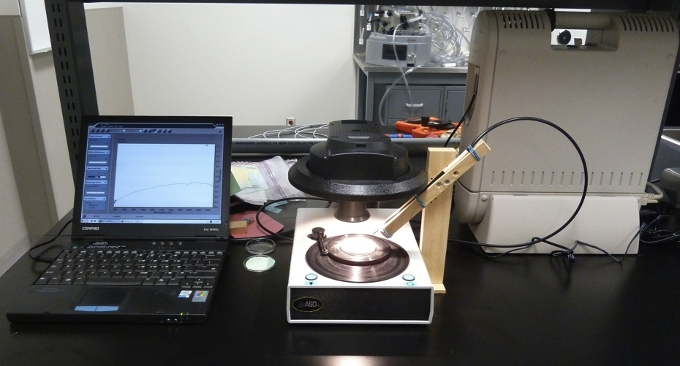

Figure 1 : Color Analysis with FieldSpecPro

1. PROCEDURES
   1. Samples Preparation

Work with dried samples already sieved at 2.00mm (cf SOP – sample preparation).

Use a plastic bag and a roller to extract fine particles from the sample. Then sieve the sample at 0.063mm.

Get sieved materials on a sheet of paper and store it in a plastic bag indicating sample’s name. The amount of sieved materials should be around 7g.

Keep the sieve and the work area clean between two samples using paper towels, brush and hair dryer in order to avoid cross-contamination.

* 1. Samples colour analyses

First, turn the spectroradiometer on (when the computer is on without the instrument being on, small currents are generated in the communication lines, which may cause damage to the instrument electronics over extended periods).

The spectroradiometer needs at least 30 minutes warm-up time.

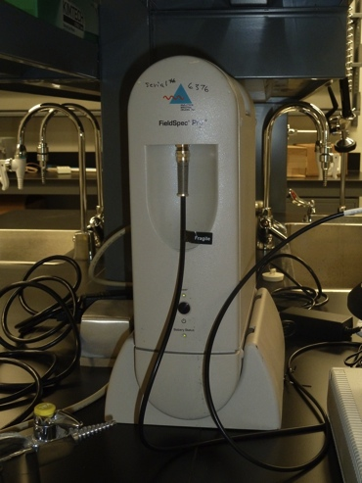

Figure 2 : Spectroradiometer, FieldSpecPro

Turn the light on and allow it to warm up for at least 15 minutes.

Then, turn the computer on.

Enter the controlling software, RS3, from the windows desktop. A window, as follow, opens.

Spectra should be collected in reflectance mode: X-axis is wavelength and Y-axis is reflectance. If you need to change axes, collect a white reference to be able to switch axes.

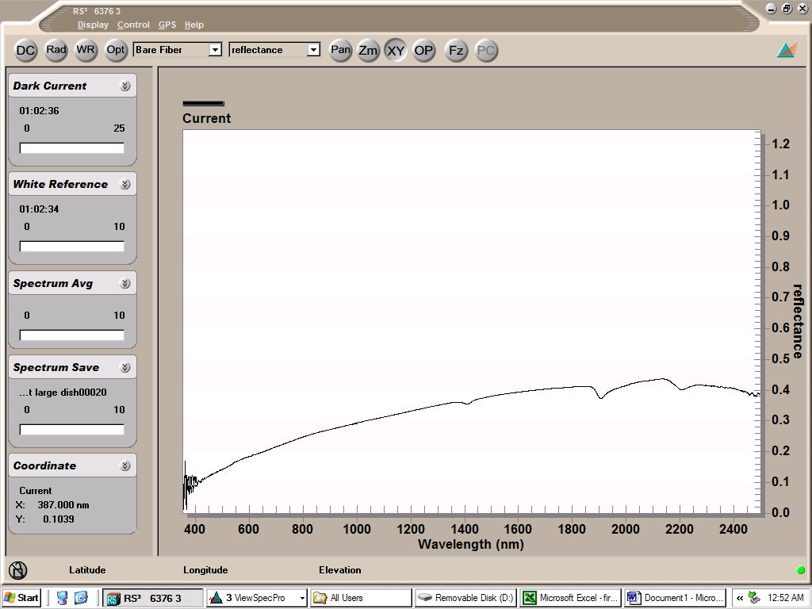

Figure 3 : RS3 software interface

White Reference Collection:

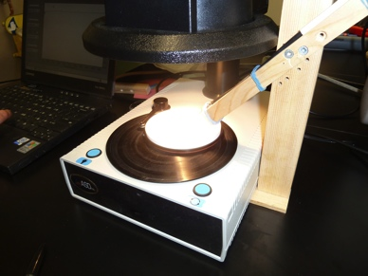The Spectralon reference panel is an optical standard and should be handled with extreme care. Always handle the reference panel from the sides to help maintain the panel’s high reflectance.

Figure 4 : White reference

Position the Spectralon reference panel on the 100mm plate and place it on the turntable.

Turn the motor on.

Collect a White Reference by clicking the **WR** button with the mouse (or pressing F4 on the keyboard).

After Dark Current is measured and White Reference is taken, you should observe the following spectrum.

**White reference should be taken before each sample analyses.**

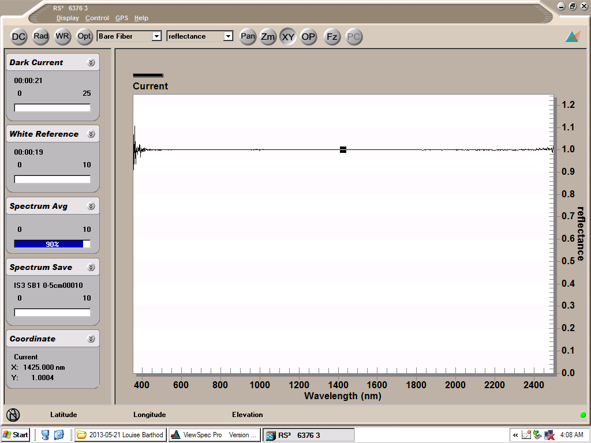

Figure 5 : White reference spectrum

Collecting sample spectrum:

Load the 52mm petri dish with sieved sample. Make sure the sample is uniform and level with a ruler as shown on the following picture.

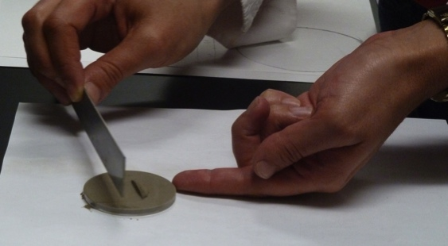

Figure 6: Loading of sample petri dish

As the sample is perfectly uniform and levelled, place the petri dish in the middle of the 100mm plate using the ring of black paper (cf next picture).

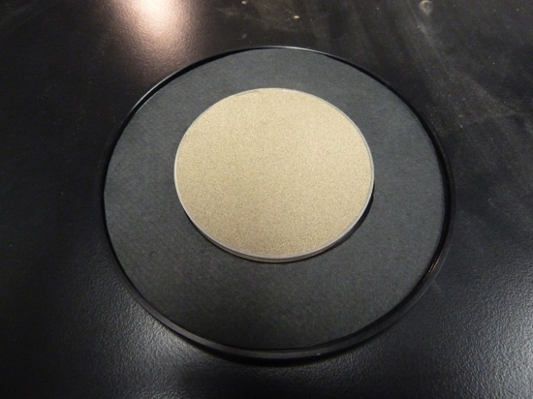

Figure 7: Sample ready for analysis

Place the 100mm plate with the petri dish on the turntable.

Turn the motor on.

The second spectrum appearing on the screen is the relative reflectance spectrum of the sample.

Wait until you see two subsequent spectra on the screen that have similar baselines (overall heights) and features before saving any data.

Spectrum Saving:

Create a folder in **C:/analysis** indicating your name and the date.

In this folder, create a new folder indicating the name of the sample.

Go back to RS3 software and **select Control > Spectrum Save**.

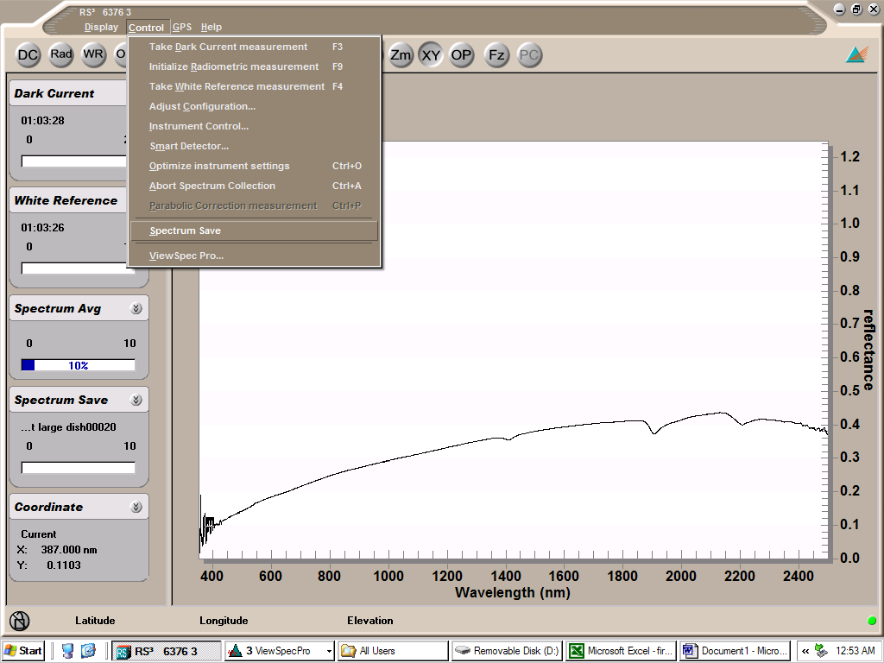

Figure 8: Spectrum saving – first step

A new window appears.

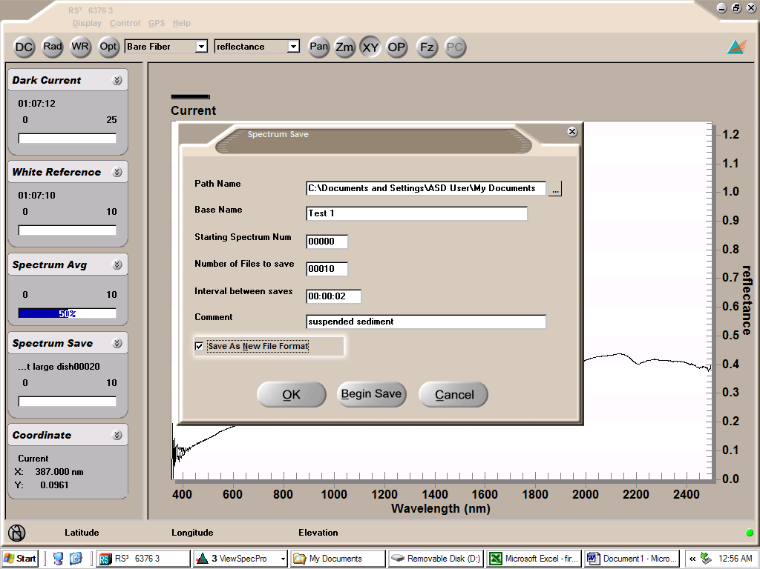

Figure 9: Spectrum saving - second step

In **Path name**, browse the name of the folder you created in **C:/analysis** to save the spectrum.

In **Base Name**, record the sample’s name.

Save 10 spectra in order to be able to average.

Press OK.

Start saving spectra by **pressing the space key** on the keyboard.

Data Saving as a table in .txt:

Enter ViewSpecPro software from Windows desktop.

Click **Open** and load data from the folder you created in **C:/analysis**.

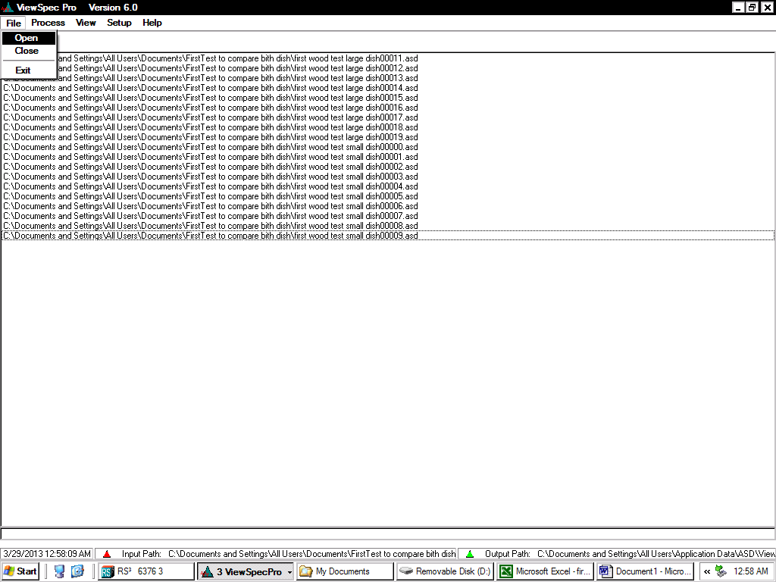

Figure 10: ViewSpecPro

Select all the files and click **View>Graph Data**. Spectra appear on your screen.

Make sure Y-axis is presenting reflectance. To modify Y-axis, select **Format>Reflectance>no derivative**.

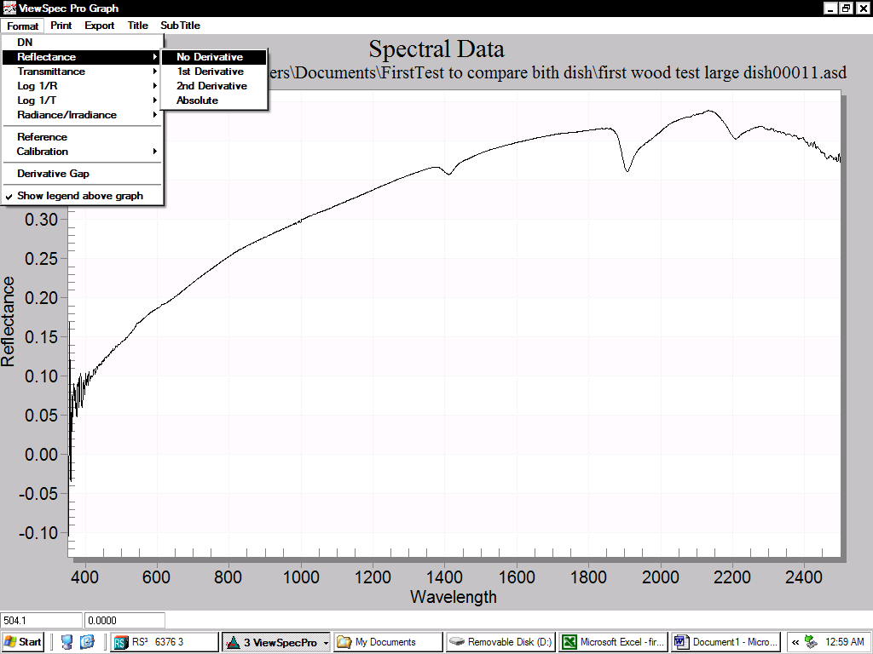

Figure 11: Y-axis modification

Select **Export** to export your data. Select **Text/Data**. Choose to export your data in the folder you created in **C:/analysis**. Enter sample’s name**.txt** in order to export your data in an excel-compatible format.

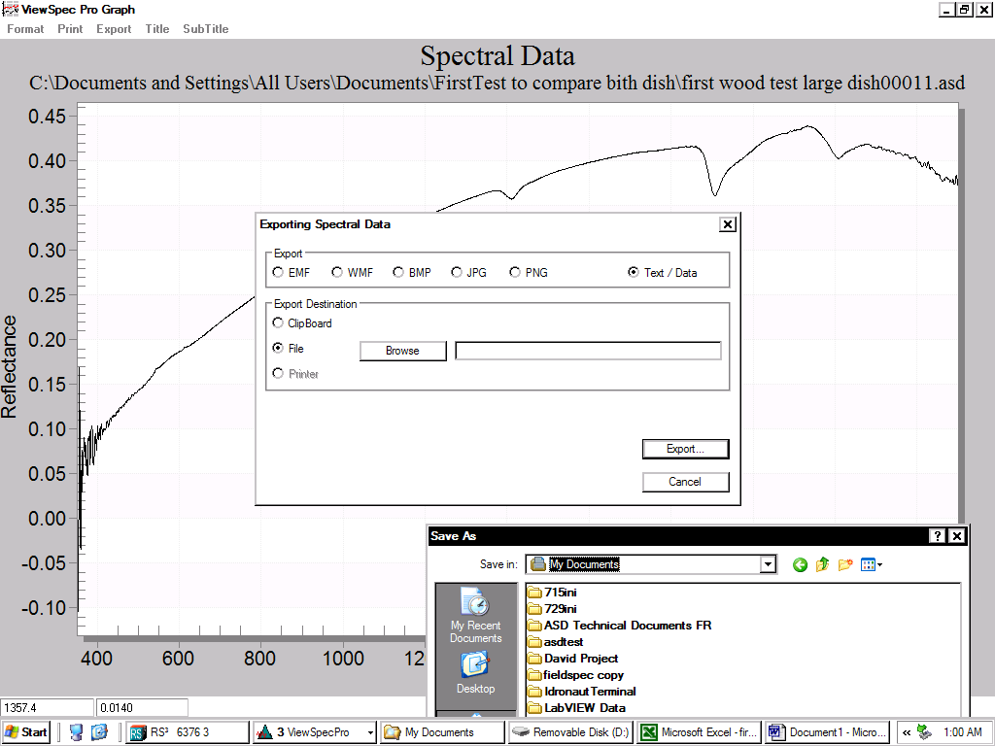

Figure 12: Data exportation - step 1

Click **Export**, a new window opens as follows. Choose to export your data in a **table**.

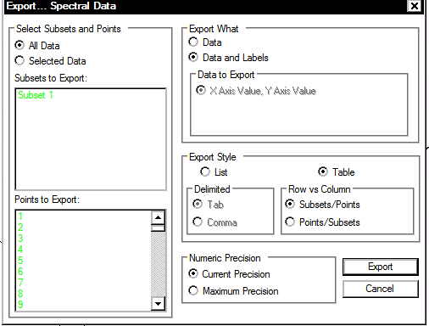

Figure 13: Data exportation-step 2

Equipment cleaning:

Clean petri dishes, 100mm plate, ruler and spoon with paper towels and water between each samples analyses. All the equipment should be free of water before loading the sample in the petri dish.

Data opening with excel:

You are now able to open you file.txt with excel selecting Tab and Comma as delimiters. You get a table with spectra names in first column, then, alternatively, the wavelength and the corresponding reflectance.

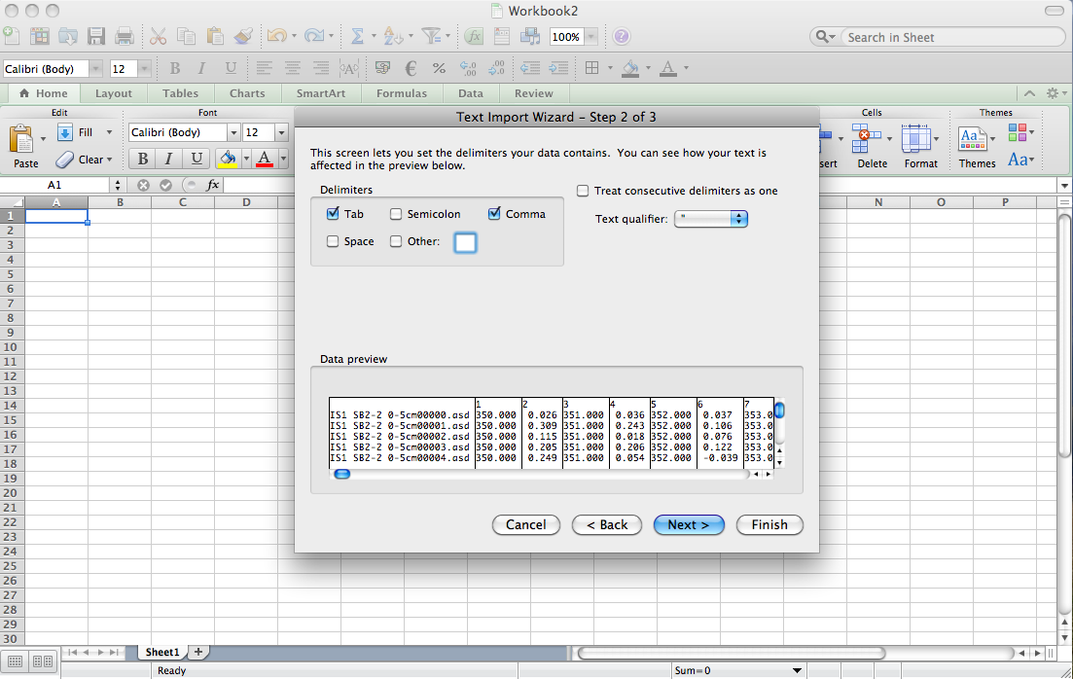

Figure 14: Data opening with excel

1. REFERENCES

## *FieldSpecPro User’s Guide*, Analytical Spectral Devices (ASD), January 2002

*Sample Turntable User Manual*, ASD Document 600610, Revision A, January 2011